-We can create a function insdie a object and it is created without the word function (the function is then called a method)

-console command stores a object and we add . to select a method

-console.log(parameter) will show input in the console log in the dev tools

-I can use x++ or x-- like in C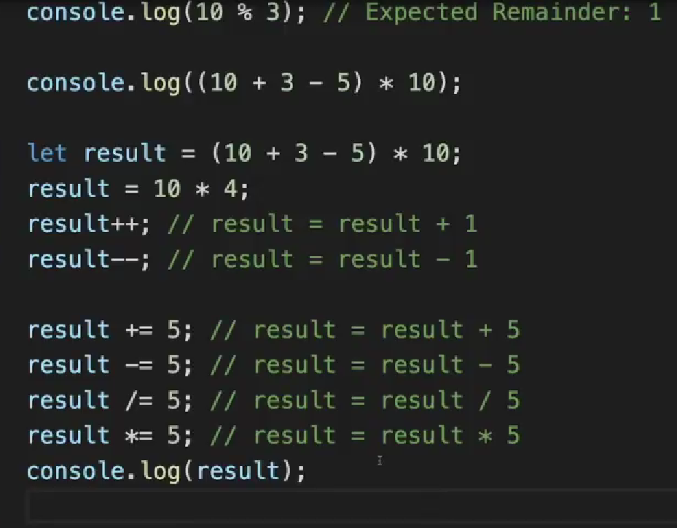

-We can use operations on text like + to combine strings(+ is the only one available)

-We can use a . on the string to access methods like length

-we can also use it on arrays